**House Popular Vote by State:**

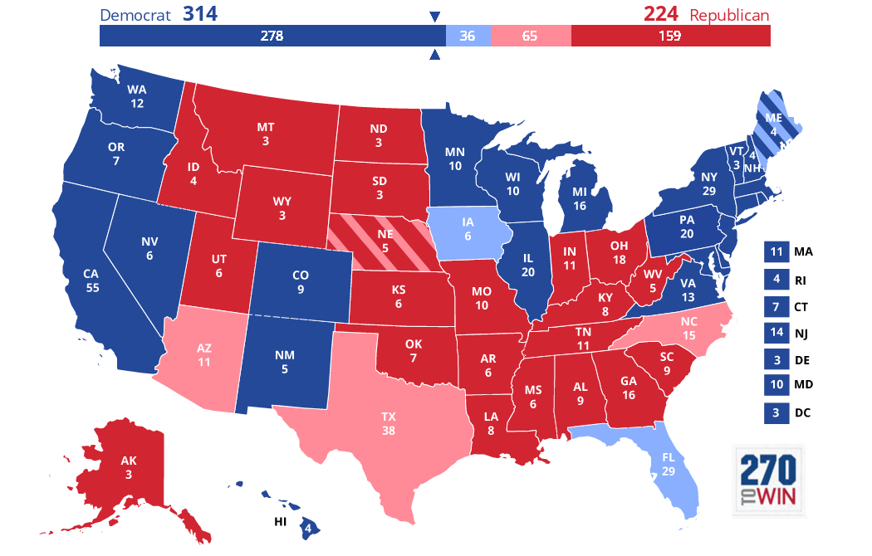

**House Map (for this year) assuming that projections are accurate**

**Exit Polls:**

**Gender**

|  | Democrat | Republican | No Answer |
| --- | --- | --- | --- |
| Male**48%** | 47% | 51% | 2% |
| Female**52%** | 59% | 40% | 1% |

**Age**

|  | Democrat | Republican | No Answer |
| --- | --- | --- | --- |
| 18-24**7%** | 68% | 31% | 1% |
| 25-29**6%** | 66% | 33% | 1% |
| 30-39**15%** | 59% | 37% | 4% |
| 40-49**16%** | 52% | 46% | 2% |
| 50-64**30%** | 49% | 50% | 1% |
| 65 and older**26%** | 48% | 50% | 2% |

**Education**

|  | Democrat | Republican | No Answer |
| --- | --- | --- | --- |
| HS or less**23%** | 48% | 51% | 1% |
| Some college**25%** | 52% | 47% | 1% |
| Associate's degree**11%** | 47% | 50% | 3% |
| Bachelor's degree**24%** | 55% | 43% | 2% |
| Advanced degree**17%** | 65% | 34% | 1% |

**Education and race**

|  | Democrat | Republican | No Answer |
| --- | --- | --- | --- |
| White college graduates**31%** | 53% | 45% | 2% |
| Whites no degree**41%** | 37% | 61% | 2% |
| Non-whites college grads**10%** | 77% | 22% | 1% |
| Non-whites no degree**18%** | 76% | 22% | 2% |

**Whites by education and gender**

|  | Democrat | Republican | No Answer |
| --- | --- | --- | --- |
| White college women**16%** | 59% | 39% | 2% |
| White non-college women**21%** | 42% | 56% | 2% |
| White college men**15%** | 47% | 51% | 2% |
| White non-college men**20%** | 32% | 66% | 2% |
| All non-whites**28%** | 76% | 22% | 2% |

**Party ID**

|  | Democrat | Republican | No Answer |
| --- | --- | --- | --- |
| Democrats**37%** | 95% | 4% | 1% |
| Republicans**33%** | 6% | 94% | N/A |
| Independents**30%** | 54% | 42% | 4% |

**Ideology**

|  | Democrat | Republican | No Answer |
| --- | --- | --- | --- |
| Liberal**27%** | 91% | 8% | 1% |
| Moderate**37%** | 62% | 36% | 2% |
| Conservative**36%** | 16% | 83% | 1% |

**Religion**

|  | Democrat | Republican | No Answer |
| --- | --- | --- | --- |
| Protestant**25%** | 38% | 61% | 1% |
| Catholic**26%** | 50% | 49% | 1% |
| Other Christian**23%** | 47% | 52% | 1% |
| Jewish**2%** | 79% | 17% | 4% |
| Muslim**1%** | N/A | N/A | N/A |
| Other religion**6%** | 70% | 28% | 2% |
| No religious belief**17%** | 70% | 28% | 2% |

**Was your vote for U.S. House today to:**

|  | Democrat | Republican | No Answer |
| --- | --- | --- | --- |
| Support Trump**26%** | 4% | 95% | 1% |
| Oppose Trump**38%** | 94% | 4% | 2% |
| Trump not a factor**33%** | 44% | 52% | 4% |

**Trump Approval:**

**Views of Donald Trump as president**

|  | **Democrat** | **Republican** | **No Answer** |
| --- | --- | --- | --- |
| **Strongly approve31%** | **5%** | **94%** | **1%** |
| **Somewhat approve14%** | **24%** | **74%** | **2%** |
| **Somewhat disapprove8%** | **63%** | **34%** | **3%** |
| **Strongly disapprove46%** | **95%** | **4%** | **1%** |

**\**

**Direction of the country**

|  | Democrat | Republican | No Answer |
| --- | --- | --- | --- |
| Right direction**42%** | 13% | 86% | 1% |
| Wrong track**54%** | 85% | 13% | 2% |

**Most important issue facing the country**

|  | Democrat | Republican | No Answer |
| --- | --- | --- | --- |
| Health care**41%** | 75% | 23% | 2% |
| Immigration**23%** | 23% | 75% | 2% |
| Economy**22%** | 34% | 63% | 3% |
| Gun policy**10%** | 70% | 29% | 1% |

**Condition of national economy**

|  | Democrat | Republican | No Answer |
| --- | --- | --- | --- |
| Excellent**17%** | 12% | 87% | 1% |
| Good**51%** | 47% | 51% | 2% |
| Not so good**23%** | 83% | 15% | 2% |
| Poor**7%** | 85% | 8% | 7% |

**View of Mueller's handling of Russia investigation**

|  | Democrat | Republican | No Answer |
| --- | --- | --- | --- |
| Approve**41%** | 79% | 19% | 2% |
| Disapprove**46%** | 28% | 71% | 1% |

**View of Kavanaugh's Supreme Court appointment**

|  | Democrat | Republican | No Answer |
| --- | --- | --- | --- |
| Support**43%** | 12% | 87% | 1% |
| Oppose**47%** | 90% | 9% | 1% |

Presidential

Harry Enten podcast: presidential approval ratings most correlated with party voted for since midterm in 1982

**Individual State Exit Polls:**

**Southwest Swing States:**

**Arizona:**

**538 Forecasted vote share**

**Result: Sinema (D) wins by approximately 2 points**

**Party ID**

|  | Sinema | McSally | No Answer |
| --- | --- | --- | --- |
| Democrats**32%** | 97% | 3% | N/A |
| Republicans**38%** | 12% | 86% | 2% |
| Independents**31%** | 50% | 47% | 3% |

**Views of Donald Trump as president**

|  | Sinema | McSally | No Answer |
| --- | --- | --- | --- |
| Approve**50%** | 11% | 87% | 2% |
| Disapprove**48%** | 94% | 5% | 1% |

**Nevada Senate:**

**Result: Rosen (D) Defeats Heller**

**Party ID**

|  | Rosen | Heller | No Answer |
| --- | --- | --- | --- |
| Democrats**33%** | 95% | 4% | 1% |
| Republicans**37%** | 5% | 92% | 3% |
| Independents**29%** | 57% | 37% | 6% |

**Views of Donald Trump as president**

|  | Rosen | Heller | No Answer |
| --- | --- | --- | --- |
| Approve**48%** | 8% | 90% | 2% |
| Disapprove**51%** | 90% | 5% | 5% |

**Midwest Swing States:**

**Indiana Senate**

**Result: Braun (R)Defeats Donnelly by 6 points**

**Views of Donald Trump as president**

|  | Donnelly | Braun | No Answer |
| --- | --- | --- | --- |
| Approve**55%** | 10% | 88% | 2% |
| Disapprove**44%** | 89% | 6% | 5% |

**Party ID**

|  | Donnelly | Braun | Brenton | No Answer |
| --- | --- | --- | --- | --- |
| Democrats**29%** | 92% | 6% | 2% | N/A |
| Republicans**39%** | 8% | 90% | 2% | N/A |
| Independents**31%** | 47% | 44% | 9% |  |
|  |  |  |  |  |

**Ohio Governor**

**Result: Dewine (R) Defeats Cordray by 4 points**

**Views of Donald Trump as president**

|  | Cordray | DeWine | No Answer |
| --- | --- | --- | --- |
| Approve**53%** | 10% | 89% | 1% |
| Disapprove**46%** | 89% | 8% | 3% |

| Cordray | DeWine | No Answer |
| --- | --- | --- |
| Democrats**33%** | 94% | 5% | 1% |
| Republicans**38%** | 6% | 92% | 2% |
| Independents**29%** | 46% | 46% | 8% |

**Pennsylvania Senate:**

Result: Democrat Casey beats Barletta by 13 points

**Party ID**

|  | Casey | Barletta | No Answer |
| --- | --- | --- | --- |
| Democrats**42%** | 93% | 6% | 1% |
| Republicans**35%** | 11% | 88% | 1% |
| Independents**22%** | 59% | 38% | 3% |

**Views of Donald Trump as president**

|  | Casey | Barletta | No Answer |
| --- | --- | --- | --- |
| Approve**45%** | 14% | 86% | N/A |
| Disapprove**55%** | 94% | 4% | 2% |

**Michigan:**

**Stabenow (D) defeats James by 6.5 points**

**Views of Donald Trump as president**

|  | Stabenow | James | No Answer |
| --- | --- | --- | --- |
| Approve**44%** | 8% | 91% | 1% |
| Disapprove**55%** | 89% | 8% | 3% |

**Party ID**

|  | Stabenow | James | No Answer |
| --- | --- | --- | --- |
| Democrats**39%** | 95% | 4% | 1% |
| Republicans**32%** | 8% | 91% | 1% |
| Independents**29%** | 46% | 50% | 4% |

**Wisconsin:**

**Senate Result: Baldwin defeats Vukmir by 11**

**Governor Result: Evers defeats Walker by 1.2**

**Party ID**

|  | **Evers** | **Walker** | **No Answer** |
| --- | --- | --- | --- |
| **Democrats34%** | **92%** | **8%** | **N/A** |
| **Republicans34%** | **5%** | **95%** | **N/A** |
| **Independents32%** | **52%** | **45%** | **3%** |

**2489 Respondents**

**Views of Donald Trump as president**

|  | **Evers** | **Walker** | **No Answer** |
| --- | --- | --- | --- |
| **Approve48%** | **12%** | **87%** | **1%** |
| **Disapprove52%** | **88%** | **10%** | **2%** |

**Missouri Senate:**

**Result: Hawley deats McCaskill by 6 points**

**Party ID**

|  | McCaskill | Hawley | No Answer |
| --- | --- | --- | --- |
| Democrats**31%** | 93% | 6% | 1% |
| Republicans**37%** | 7% | 92% | 1% |
| Independents**32%** | 46% | 51% | 3% |

**Views of Donald Trump as president**

|  | McCaskill | Hawley | No Answer |
| --- | --- | --- | --- |
| Approve**53%** | 8% | 90% | 2% |
| Disapprove**46%** | 92% | 7% | 1% |

**Minnesota Senate:**

**Results: Klobuchar (D) wins by 24 points**

**Smith (D) wins by 10.5 points**

**Views of Donald Trump as president**

|  | **Klobuchar** | **Newberger** | **No Answer** |
| --- | --- | --- | --- |
| **Approve45%** | **18%** | **81%** | **1%** |
| **Disapprove53%** | **94%** | **5%** | **1%** |

**Views of Donald Trump as president**

|  | **Smith** | **Housley** | **No Answer** |
| --- | --- | --- | --- |
| **Approve45%** | **10%** | **87%** | **3%** |
| **Disapprove53%** | **91%** | **7%** | **2%** |

**Party ID**

|  | **Klobuchar** | **Newberger** | **No Answer** |
| --- | --- | --- | --- |
| **Democrats39%** | **98%** | **2%** | **N/A** |
| **Republicans32%** | **18%** | **81%** | **1%** |
| **Independents29%** | **62%** | **36%** | **2%** |

**2123 Respondents**

**Party ID**

|  | **Smith** | **Housley** | **No Answer** |
| --- | --- | --- | --- |
| **Democrats39%** | **96%** | **4%** | **N/A** |
| **Republicans32%** | **9%** | **90%** | **1%** |
| **Independents29%** | **53%** | **43%** | **4%** |

**2101 Respondents**

**Iowa Governor:**

**Reynolds (R)defeats Hubbell by 3 points**

**No exit polls (Why CNN?) However, Dems did take 3 of 4 house seats and win the house popular vote**

**Mixed Bag: here**

**Sunny States (FL, TX, GA):**

**Florida Senate:**

**Result: TBD but likely Scott (R) defeats Nelson by 0.15 points**

**Party ID**

|  | **Nelson** | **Scott** | **No Answer** |
| --- | --- | --- | --- |
| **Democrats33%** | **91%** | **8%** | **1%** |
| **Republicans37%** | **9%** | **91%** | **N/A** |
| **Independents30%** | **55%** | **44%** | **1%** |

**3109 Respondents**

**Views of Donald Trump as president**

|  | **Nelson** | **Scott** | **No Answer** |
| --- | --- | --- | --- |
| **Approve51%** | **10%** | **89%** | **1%** |
| **Disapprove48%** | **89%** | **8%** | **3%** |

**Texas Senate:**

**Result: Cruz (R) beats O’Rourke by 2.5 points**

**Party ID**

|  | **O'Rourke** | **Cruz** | **No Answer** |
| --- | --- | --- | --- |
| **Democrats34%** | **92%** | **8%** | **N/A** |
| **Republicans38%** | **8%** | **91%** | **1%** |
| **Independents27%** | **50%** | **47%** | **3%** |

**Views of Donald Trump as president**

|  | **O'Rourke** | **Cruz** | **No Answer** |
| --- | --- | --- | --- |
| **Approve49%** | **6%** | **94%** | **N/A** |
| **Disapprove49%** | **92%** | **7%** | **1%** |

**Georgia Governor:**

**Result: Likely Kemp by 1.2 to 1.5 points (waiting to see about a runoff)**

**Party ID**

|  | **Abrams** | **Kemp** | **No Answer** |
| --- | --- | --- | --- |
| **Democrats33%** | **97%** | **2%** | **1%** |
| **Republicans38%** | **3%** | **97%** | **N/A** |
| **Independents28%** | **54%** | **44%** | **2%** |

**Views of Donald Trump as president**

|  | **Abrams** | **Kemp** | **No Answer** |
| --- | --- | --- | --- |
| **Approve52%** | **8%** | **91%** | **1%** |
| **Disapprove47%** | **93%** | **6%** | **1%** |

**The Weird Races: Heavy R States where a Senate Democrat won:**

**Montana:**

**Result: Tester (D) wins by 3.1 points over Rosendale**

**Party ID**

|  | **Tester** | **Rosendale** | **No Answer** |
| --- | --- | --- | --- |
| **Democrats25%** | **98%** | **1%** | **1%** |
| **Republicans29%** | **7%** | **92%** | **1%** |
| **Independents45%** | **50%** | **45%** | **5%** |

**2151 Respondents**

**Views of Donald Trump as president**

|  | **Tester** | **Rosendale** | **No Answer** |
| --- | --- | --- | --- |
| **Approve51%** | **9%** | **88%** | **3%** |
| **Disapprove48%** | **95%** | **3%** | **2%** |

**West Virginia:**

**Result: Manchin (D) wins by 3.2 points**

**Party ID**

|  | **Manchin** | **Morrisey** | **No Answer** |
| --- | --- | --- | --- |
| **Democrats35%** | **85%** | **12%** | **3%** |
| **Republicans35%** | **17%** | **81%** | **2%** |
| **Independents30%** | **50%** | **46%** | **4%** |

**Views of Donald Trump as president**

|  | **Manchin** | **Morrisey** | **No Answer** |
| --- | --- | --- | --- |
| **Approve63%** | **28%** | **69%** | **3%** |
| **Disapprove35%** | **92%** | **4%** | **4%** |